Movie Landing Page Website Design

Name: KURRA LS SANTHOSH SRINIVAS

Mail Id : saisantoshkurra@gmail.com

Phn No : 6300657572

Roll N0 : 20HU1A0566

College Name : Chebrolu engineering college

**Source Code:**

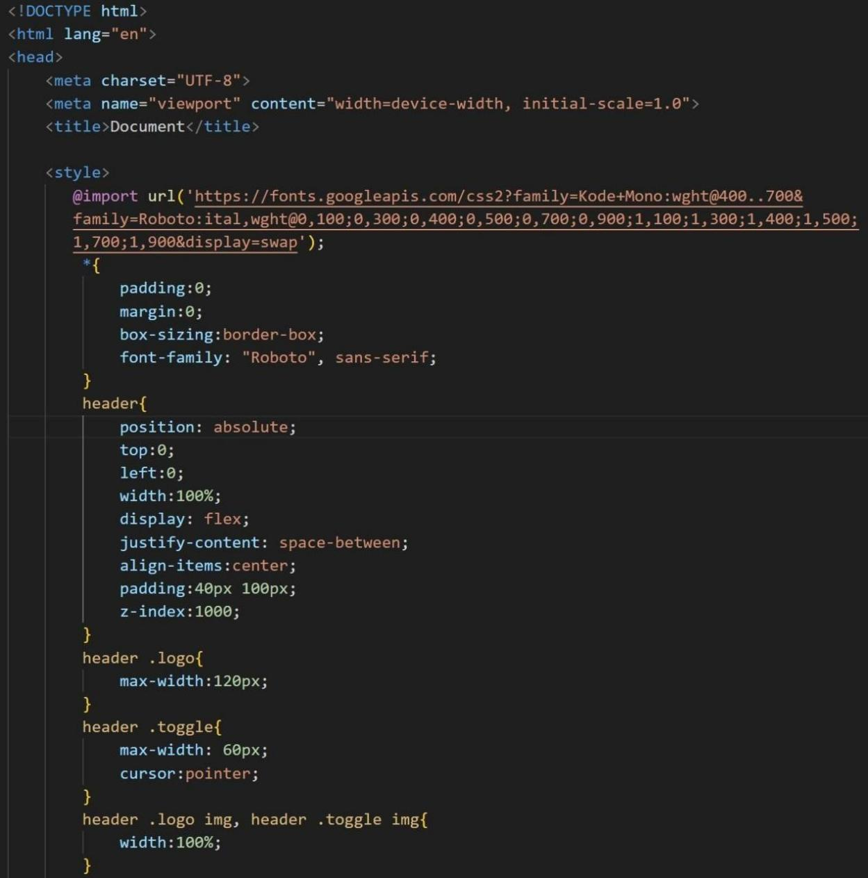

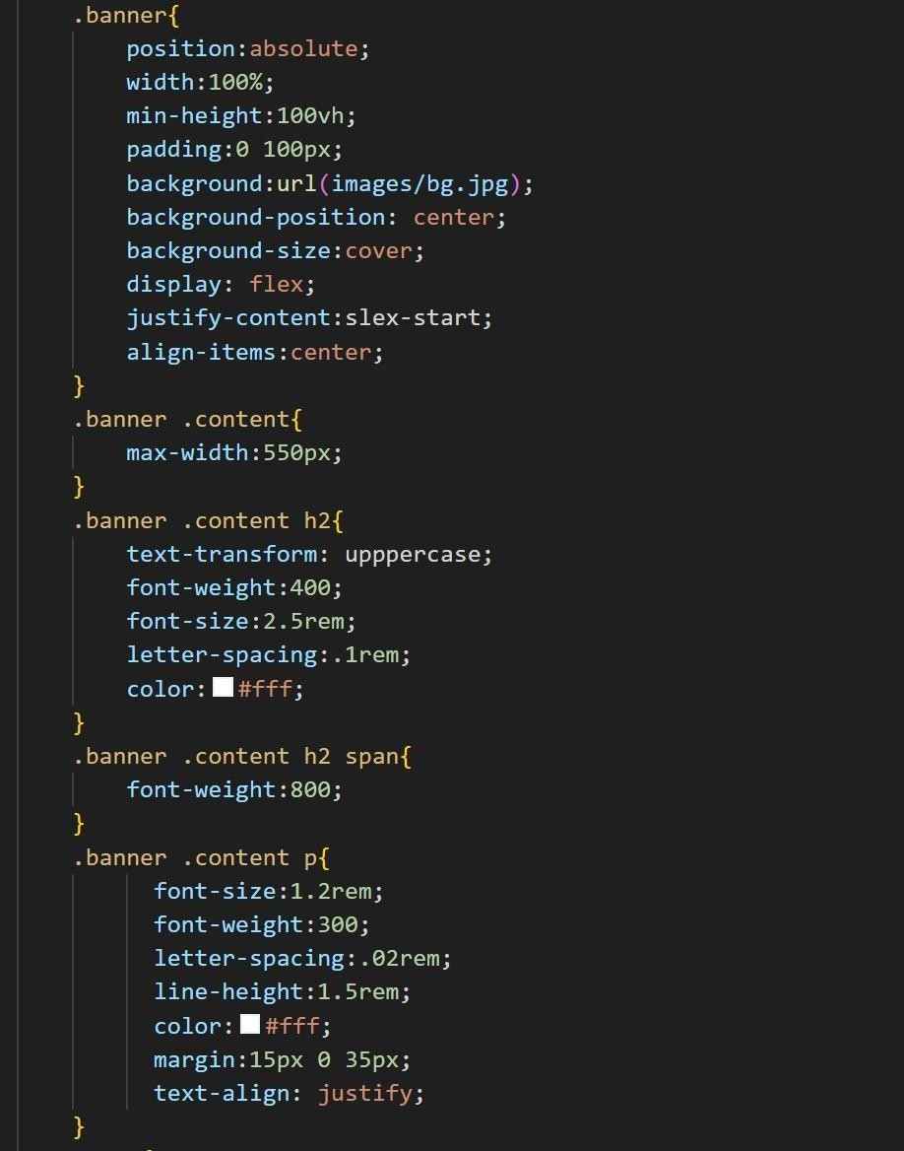

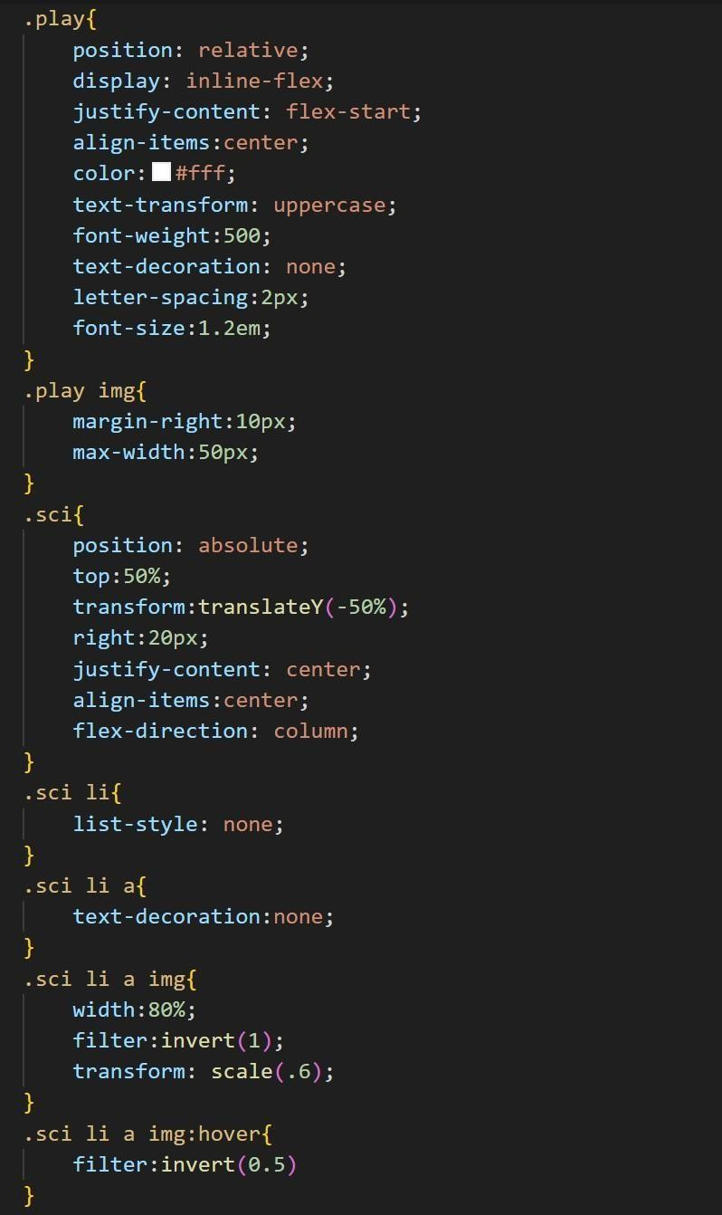

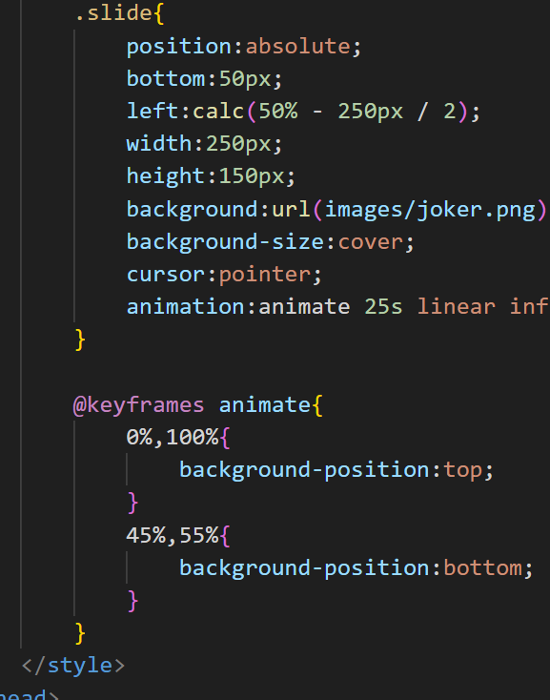

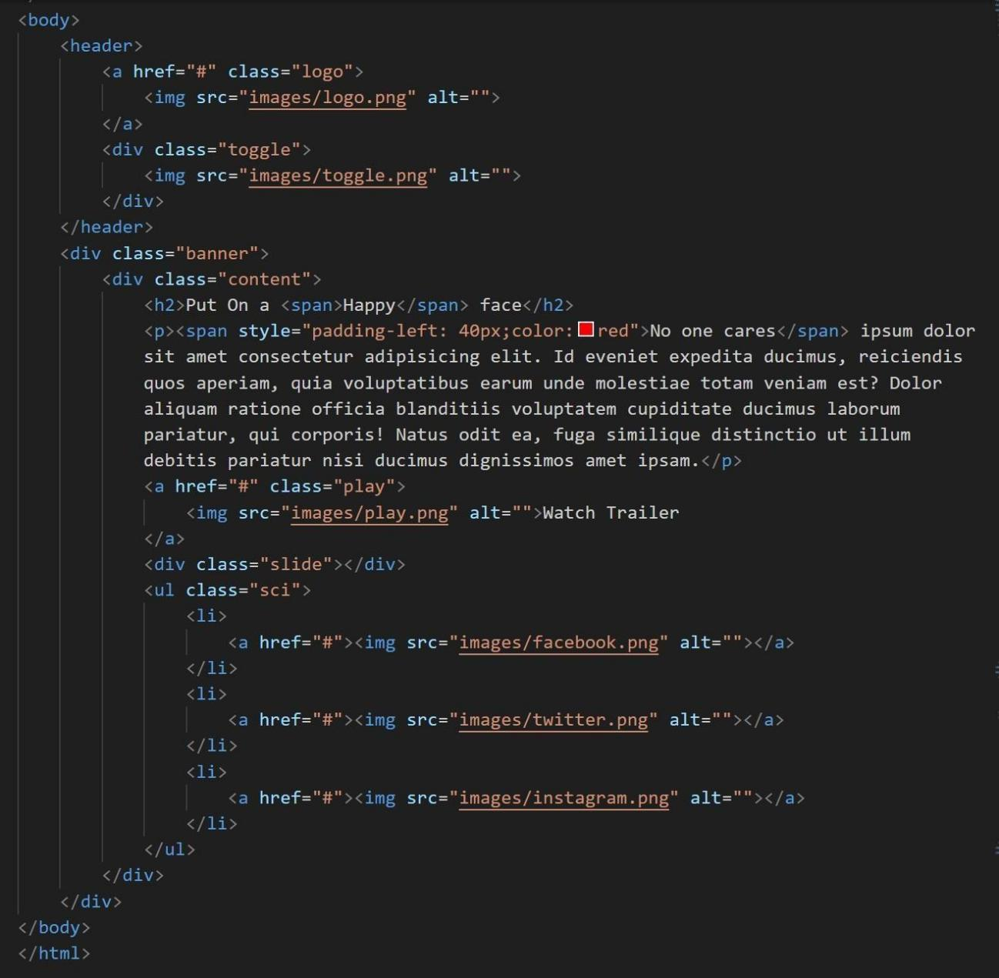



**Output :**